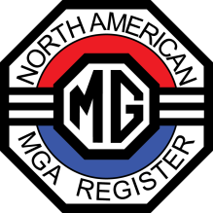
Written by: Carolyn Shepard
Welcome and a big “Hi y’all” to NAMGAR GT 48.
This year’s National GT car show is located in the Blues City, Memphis Tennessee, located on the picturesque Mississippi at the midpoint of the USA. FedEx choose this city as the main headquarters based on the easy accessibility both from the north on I 55 and the south on I 40. Known for Blues music and the King of Rock and Roll, Elvis Presley, tourist opportunities abound for everyone. Mark your calendar for June 12-16, 2023.
This year’s car show site is uniquely positioned on Marshall Avenue in front of the EDGE Motor Museum that focus’ on Speed and the development of the sports car in the USA. Did you know that the MGTD is the precursor of the Ford Thunderbird and the Chevrolet Corvette? Service men returning from WWII remember the sports cars from across the pond. When they finally moved to the suburbs where purchasing not only one car but two cars became the norm and their disposable income allowed, the MGTD became one of the first sports cars these veterans purchased. US car manufactures grasped this opportunity to design something both distinctive and powerful. In the early 1950’s to the end of the 1970’s, Ford and Chevrolet created and competed in the sports car market centered on driver’s desire for SPEED. The Edge Motor Museum under the guidance of Richard Vining, the museum designer and Bob Watkins, the GT 48 show coordinator, will be free to all GT 48 participants
The events and activities at GT 48 highlight the best in Memphis. A tour of Graceland, the home of Elvis Presley is a must for first time Memphis tourists. A poker run ending at the Collierville town square (voted the best in the country) and a MOJO Backbeat bus tour of the city with a local blues guitar player as the guide, enhance the activity list. For those who prefer to adventure on their own, many self-driving tours around featured attractions are available. Beale Street, The Civil Rights Museum where Martin Luther King was assassinated, the ducks at the famous Peabody hotel and the St. Jude’s medical complex that provides free care to children with cancer, are a few of the many sites to see while visiting Memphis, TN
John Twist from Michigan will perform his famous rolling tech sessions at GT 48. His expertise in the area of MG’s is venerated throughout the country. Additional Tech sessions are organized throughout the day and even one for the ladies.
Registration is completed either through the NAMGAR web site NAMGAR.com or through printing a paper form located in the MGA magazine or online. Payment is done by using a credit card or sending a registration form and check through the mail. Please register as soon as possible to secure your place in this fun filled GT event. Renewing old friendships, commiserating about and displaying our dream MGA’s are the reasons to attend this National Meet.
The Memphis Hilton Hotel on Ridge Lake Rd in East Memphis is the heart of all GT 48 activities and will host the awards banquet after the show. The GT room rate is $149 per night. Secure parking is next to the hotel and accommodates trailers. The hotel information along with the URL to be used for online reservations is located at the top of the registration form. Register early and please make sure you mention GT-48. The use of hotel points is allowed.
https://www.hilton.com/en/book/reservation/deeplink/?ctyhocn=MEMPHHF&groupCode=NAMG22&arrivaldate=2023-06-10&departuredate=2023-06-16&cid=OM,WW,HILTONLINK,EN,DirectLink&fromId=HILTONLINKDIRECT
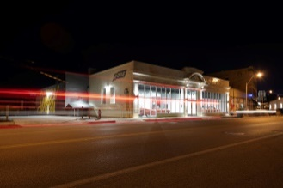https://www.edgemotormuseum.com/
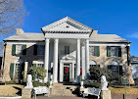https://www.graceland.com/mansion
https://www.civilrightsmuseum.org/
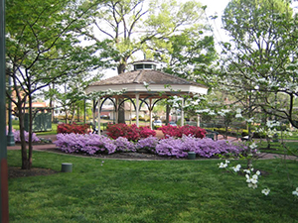https://mainstreetcollierville.org/
https://www.backbeattours.com/tours/memphis-mojo-tour/

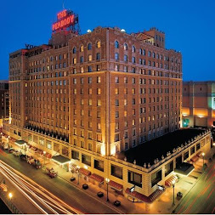https://www.peabodymemphis.com/?utm_source=local-directories&utm_medium=organic&utm_campaign=travelclick-localconnect-featured

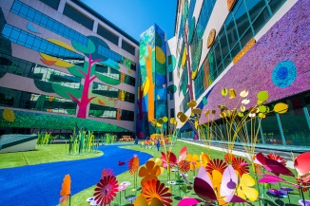https://www.stjude.org/

